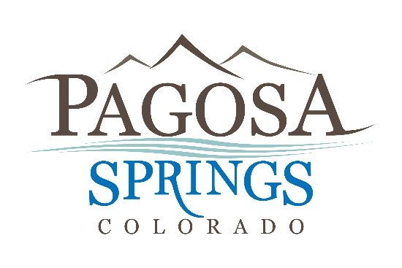 | Town of Pagosa Springs  551 Hot Springs Boulevard  Post Office Box 1859  Pagosa Springs, CO 81147  Phone: 970.264.4151  Fax: 970.264.4634
For Immediate Release
May 1, 2020 1:30 pm

For More Information Contact:
Andrea Phillips, Town Manager (970) 264-4151 x. 236
Scott Wall, County Manager (970) 264-8302

JOINT COUNTY-TOWN LAUNCH OF A LOCAL ADOPT-A-ROAD PROGRAM

Archuleta County and the Town of Pagosa Springs are working together to launch an Adopt-A-Road Program. The Adopt-A-Road program sees to maintain the natural beauty of our region by keeping roadside litter at a minimum, while supporting local businesses, nonprofits, and other organizations.

The purpose of the program is to provide an opportunity for service organizations and volunteer groups to do a cleanup project and to interact as a team for a positive impact in the community. Many communities throughout the state have created their own "Adopt a Road" programs, modeled after the national program. Groups can pick a road or section of road and, through their group, coordinate clean up days for that stretch of road. A sign can be installed indicating the group's adoption of the road.
﻿
The County and Town have received complaints from residents about trash and debris in the right of ways. The right of ways tend to become littered, and this is especially apparent in the spring. Staff does not have the time to go down every roadside area to clean up the debris. Through the program, the County and Town would provide trash bags, safety visibility vests, and would order adoption signs specific to the organization. The County and Town would provide supplies and a point of contact for the volunteer groups and after a group performed a cleanup, staff would pick up the bags. Groups would not pick up hazardous materials (if present) or dead animals but repost those items to their contact.
﻿
The County and Town have prepared lists of roads that are available for adoption. These roads include some of the most heavily traveled in the County, and also come sof the dirtiest. Some roads provide opportunities for groups to pick trash on both Town and County jurisdictions, providing a shared benefit. CDOT has a similar program for state highways and this program does not propose to have groups picking up litter on the highway.

Interested parties can contact Jamie Jones at jjones@archuletacounty.org or Martin Schmidt at mschmidt@pagosasprings.co.gov for more information.

####

